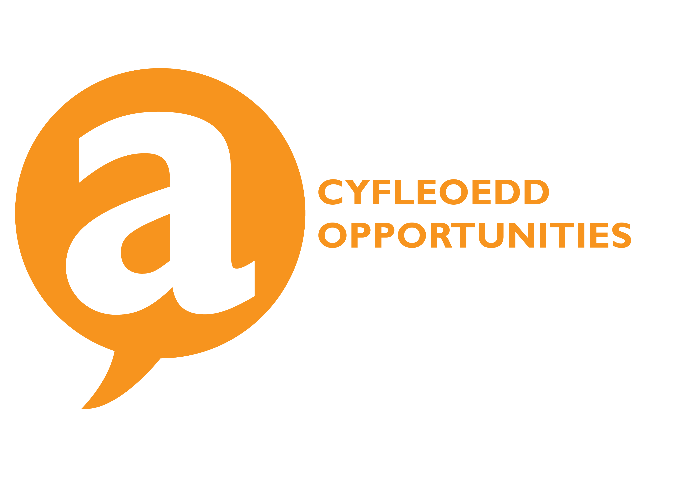

Student Groups Grant Application Form 2017/18

Name of Student Group |  | AberCompSoc
Contact Details |  |  | E Mail(Aber Uni) |  |  | Phone(Mob)
President |  | Samantha Pendleton | sap21@aber.ac.uk |  |  | 07562683066
Secretary |  | Nicholas Rostant | ndr2@aber.ac.uk |  |  | +44 07507419048
Treasurer |  | Jack Webb
At what level does your Sports play?(BUCS, Community, Social) |  | N/A
Number of members in 2016/17  How much will your membership be in 2017/18? |  |  |  |  |  |  | 48  £ 0
Please give an overview of your Students Group and how a grant would benefit you?
AberCompSoc is a society for students interested in computer science and related fields, we aim to provide a welcoming community and support for various extra-curricular projects and events organised by our members.

Being a relatively new society with an eye towards growing our membership we have strived to keep membership fees as minimal as possible to avoid them becoming a barrier to entry. As such we are seeking this grant to assist in financing our events and projects and to continue to invest in our growing membership.

How do your members benefit from being a part of your Student Group?
Our members benefit from being part of a community with similar interests and a wide range of experience. Whatever the specific field of interest a member has they can often find others within the society who is willing to offer their knowledge and assistance.

We aim to encourage our members to take part in various projects together which provide valuable skills and experience as members move into industry. Ideally these projects also provide direct benefits to our members (such as the current attempt to create a society cloud server to which we would be able to offer the use of which to our members for personal and communal uses).

How does the Students’ Union benefit from your Student Group?
We provide publicity for the Union representing them at various events thrroughout the year and abroad during our trips. This year we aim to take part in Union charity events to assist in raising awareness for good causes.

What are your project costs for 2017/18.
(i.e Equipment purchases)
1. Marketing materials (Hoodies, stickers etc.)

2. Funding to support internal projects and events

3. Social funding

Total Project cost?
Please supply a break down of costs.
By signing below you agree to provide this information.

Deadline for application is 8th May 2017 at 12pm.

Please return completed form (PDF) to:union.activiteis@aber.ac.uk
President | SAMANTHA PENDLETON |  |  |  | Signed
Treasurer | JACK WEBB |  |  |  | Signed
Secretary | NICHOLAS ROSTANT |  |  |  | Signed
Date |  |  |  |  |  |  | 07/05/2017

Thank you for your application, it will be processed and you will be notified of your allocation via email.

The Opportunities Team

